Project Title
Full Stack Blog Management Application

1. Project Overview
This project is a Full Stack Blog Management Application developed using the MERN stack. The application allows users to create, view, edit, and delete blog posts through a user-friendly interface. It demonstrates real-world implementation of frontend-backend integration, RESTful APIs, and database operations.

2. Objectives of the Project
- To understand full stack web application architecture
- To implement CRUD operations using REST APIs
- To integrate frontend with backend services
- To work with MongoDB database using Mongoose
- To follow professional project structure and coding practices

3. Technology Stack

Frontend
- React.js
- React Hooks
- React Router DOM
- CSS

Backend
- Node.js
- Express.js

Database
- MongoDB
- Mongoose

4. Project Architecture
The project follows Client–Server Architecture where:
- Frontend handles user interaction
- Backend manages APIs and business logic
- MongoDB stores blog data

5. Project Directory Structure

Backend Structure
blogapp/
├── backend/
│ ├── server.js
│ ├── .env
│ ├── config/
│ │ └── DB.js
│ ├── models/
│ │ └── blogModel.js
│ ├── routes/
│ │ └── postRoutes.js
│ ├── uploads/

Frontend Structure
frontend/
├── src/
│ ├── App.jsx
│ ├── App.css
│ ├── main.jsx
│ ├── index.css
│ ├── assets/components/
│ ├── AddPost.jsx
│ ├── Card.jsx
│ ├── CreatePost.jsx
│ ├── EditPost.jsx
│ ├── ViewPost.jsx
│ ├── PostDetail.jsx

6. Core Features
- View all blog posts
- View individual blog post details
- Create a new blog post
- Edit existing blog posts
- Delete blog posts

7. Functional Modules

Blog Management Module
- Add new blog posts
- Edit blog content
- Delete blog posts

Post Display Module
- Display list of all posts
- Show detailed post view

8. User Interface Description

Home Page
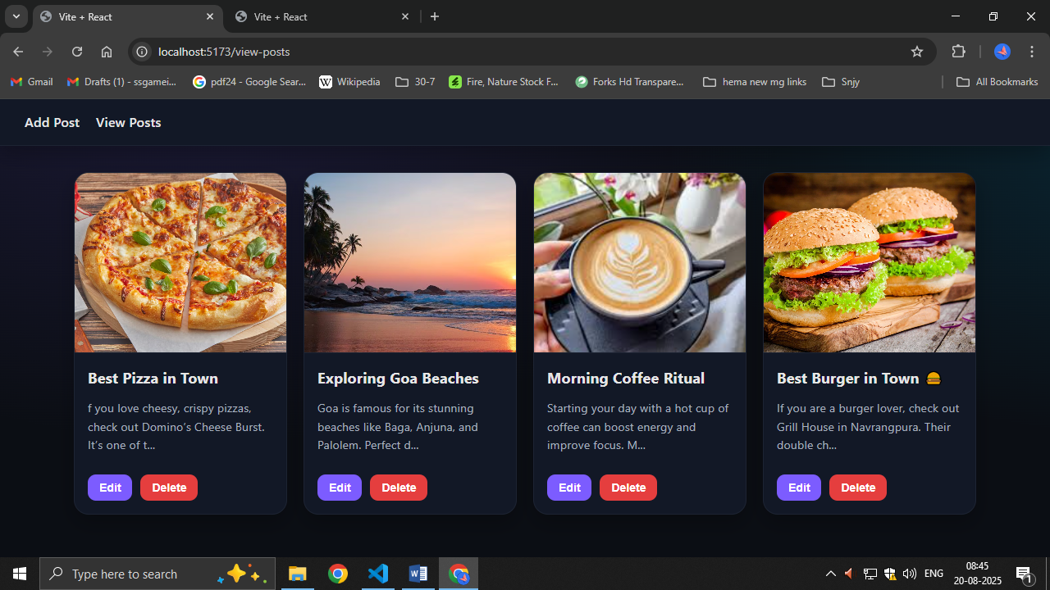
- Displays all blog posts in card layout

Add Post Page
- Form to create a new blog post
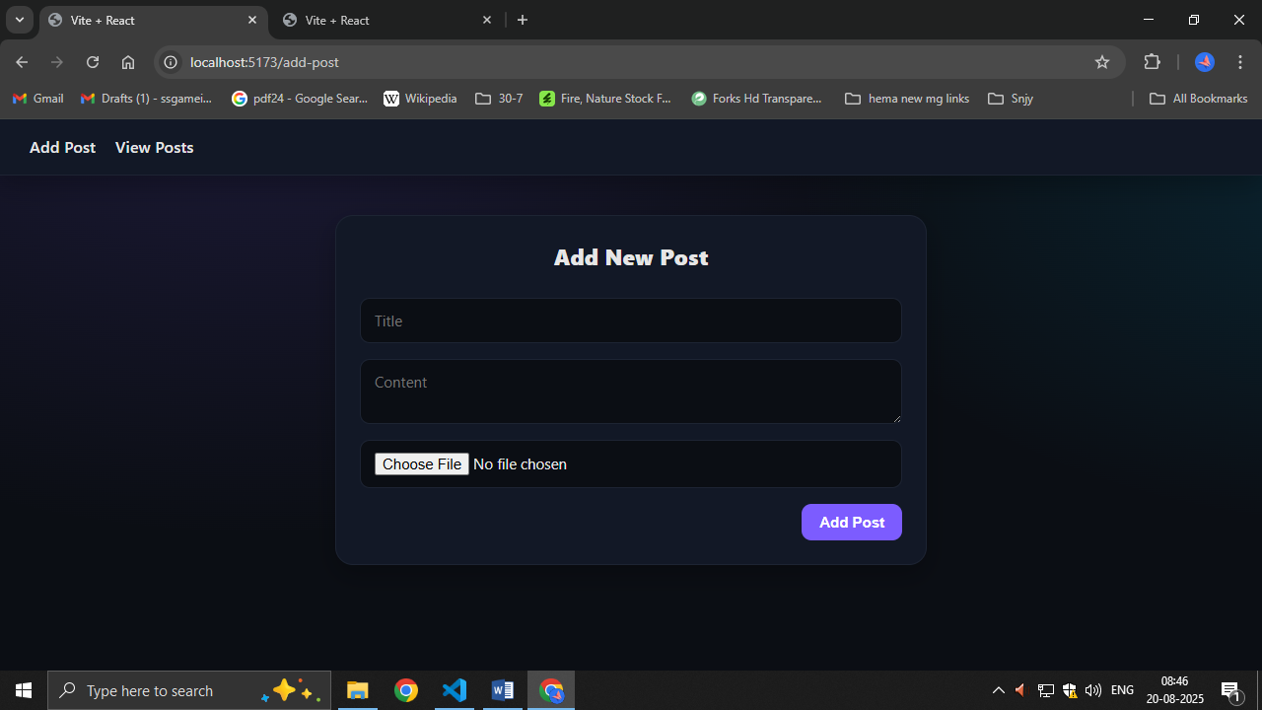

Edit Post Page
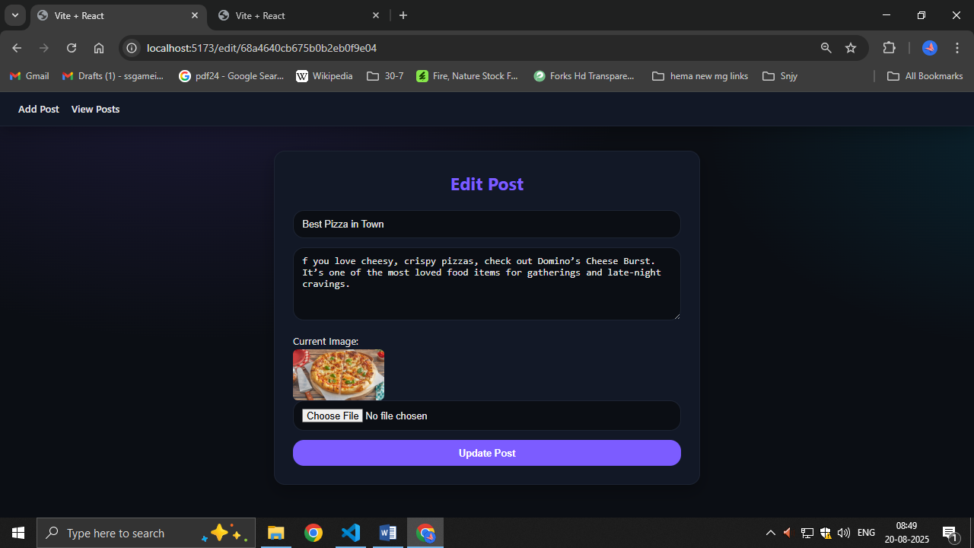
- Update existing blog post data

Post Detail Page
- Shows full blog content with title and description
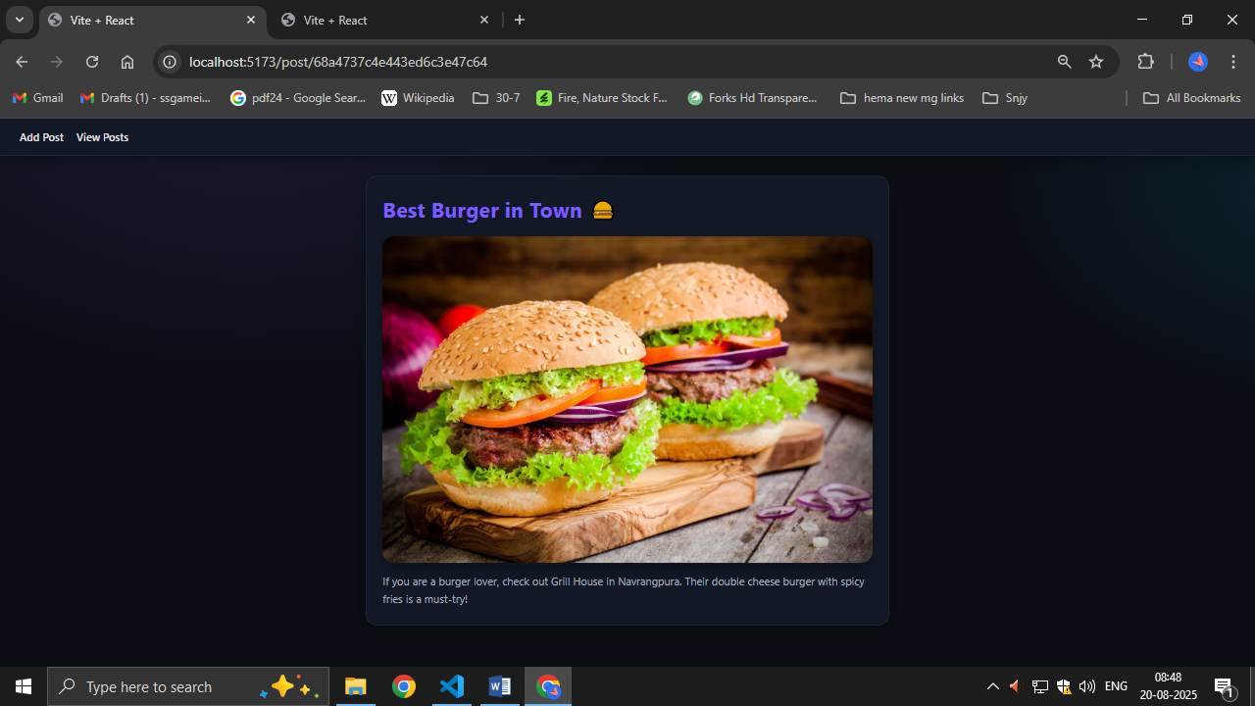

9. Security & Validation
- Input validation on frontend
- API error handling
- Environment variable usage for database security

